**Project Report**

**Title:** Argus is cybersecurity, monitoring, or data analysis tool. It is used in network security, threat detection, and real-time monitoring to keep system safe and efficient.

**Course:** CEH Class

**Student Name:** Laxman

**Objective**

In this assignment, we will see how to install Argus and see how to argus information-gathering tool used for network monitoring and analysis. Argus provides real-time network traffic auditing. We will go through the installation process, configuration, and basic usage to understand how Argus helps in tracking and analysing network activity effectively.

**Configuration Details**

**Operating System (Kali Linux):**

**• Operating System:** Kali Linux

**• RAM:** 4 GB

**• Processors:** Intel i3/i5 or AMD Ryzen 3

**• Storage:** 30 GB

**• Network Adapter:** NAT

**VMware Workstation Pro/Player (VM):**

**• Operating System: Workstation Pro/Player**

**• RAM:** 8 GB

**• Processors:** Intel i5/i7 or AMD Ryzen 5/7

**• Storage:** 50 GB

**• Network Adapter:** NAT

**Steps Performed**

**Step 1: Setup the Virtual Machine**

**• Description:** Start the machine and check we are in the network

**Step 2: Pinging with the google**

**Command Using:** Ping 8.8.8.8

**• Evidence**

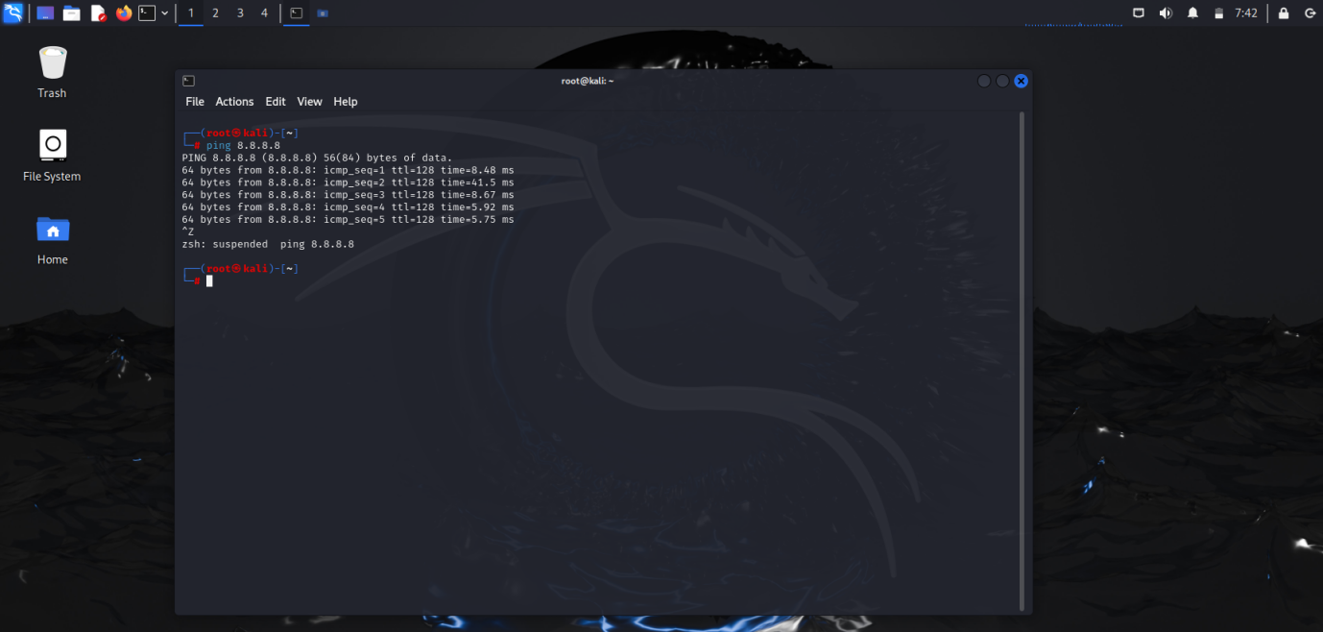

**Step 3: Argus Installation Steps**

1. Open the Firefox and Search Argus GitHub
2. Click on the First Link
3. Scroll Down and see Installation commands
4. Configure the commands step-by-step on kali Linux

**Command Using:** 1) git clone <https://github.com/jasonxtn/argus.git>

2) cd argus

3) pip install -r requirments.txt

**• Evidence**

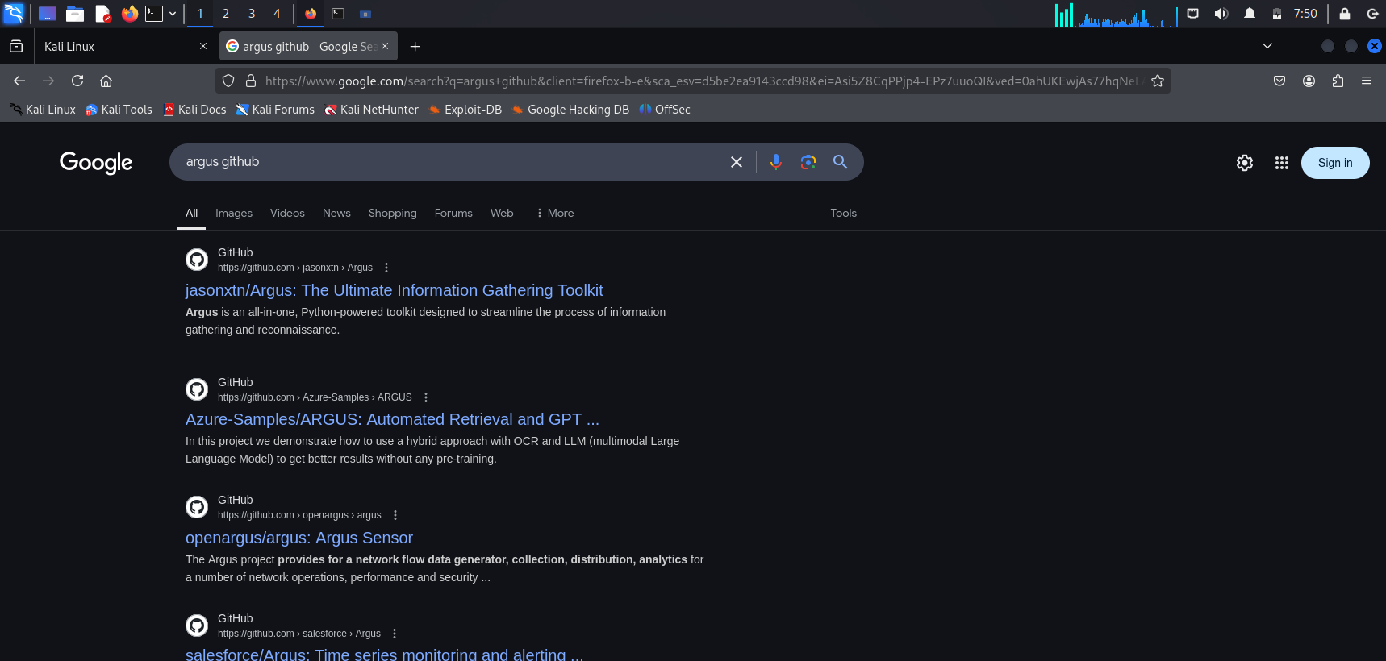

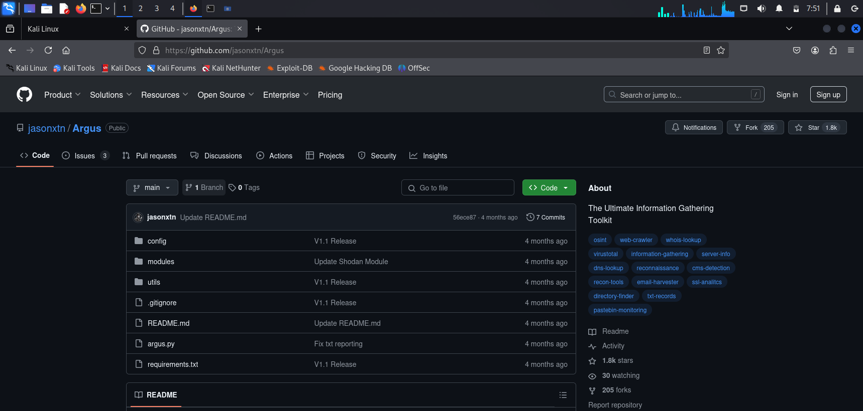

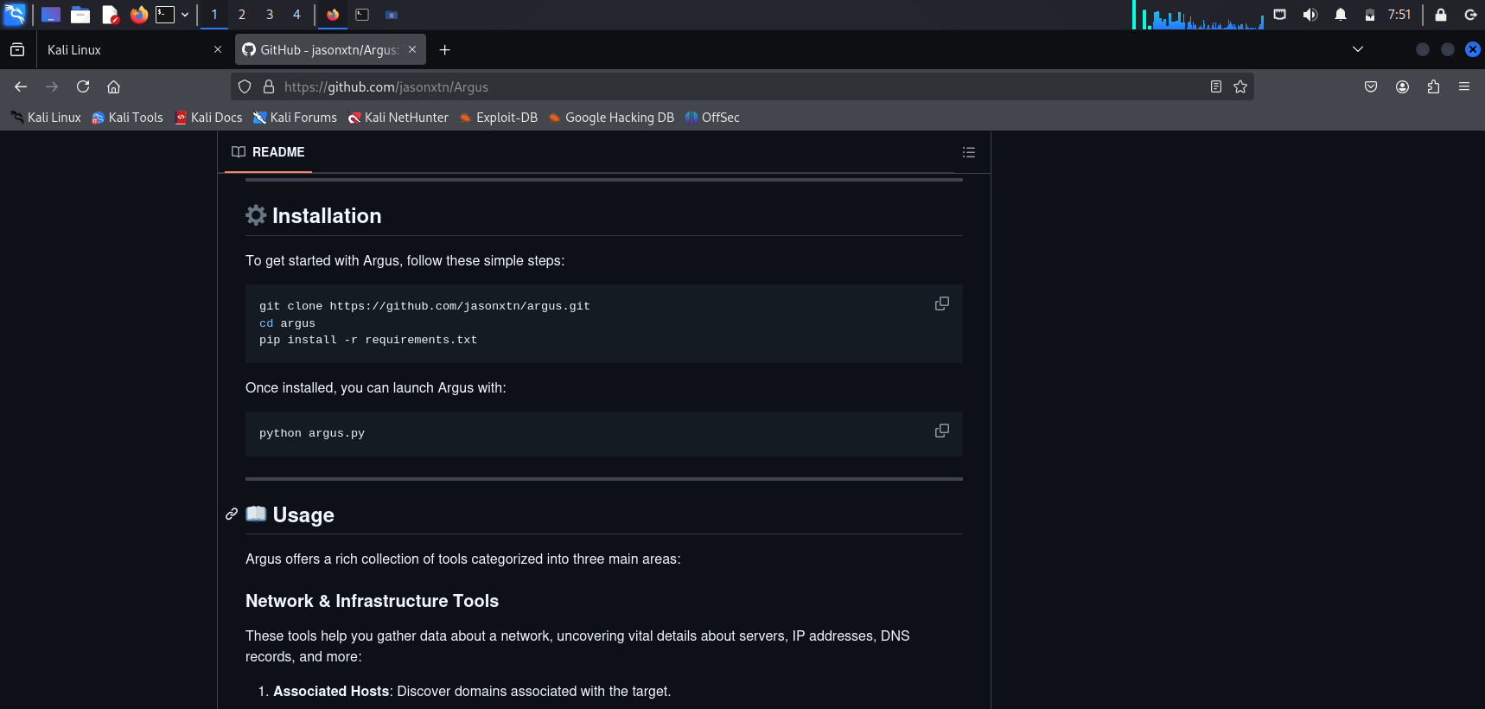

**Step 4: Scanning with argus on kali Linux**

**Command Using:** 1) cd argus

2) python3 argus.py

**•Evidence**

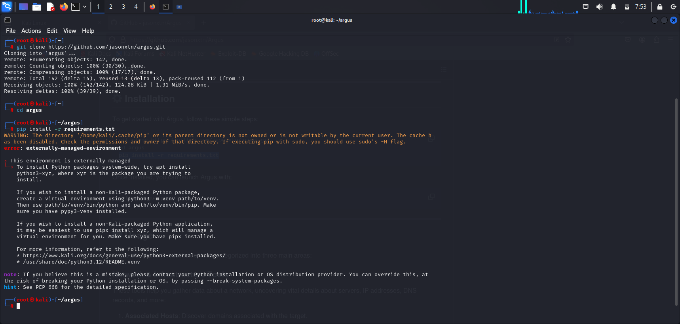

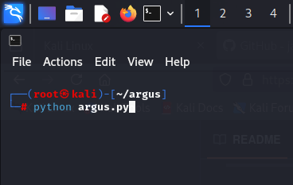

**Step 5: Argus menu Open**

**Command Using:** 1) 100

2) <http://ducatindia.com> (target domain or URL)

3) Enter and wait

**• Evidence**

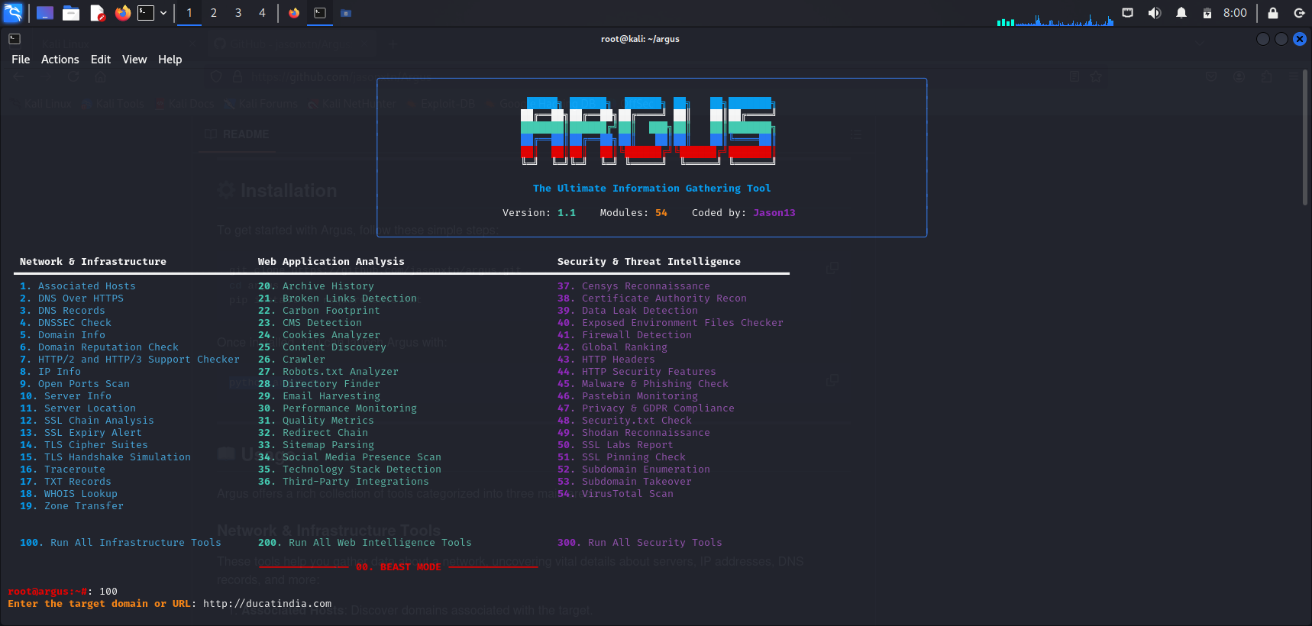

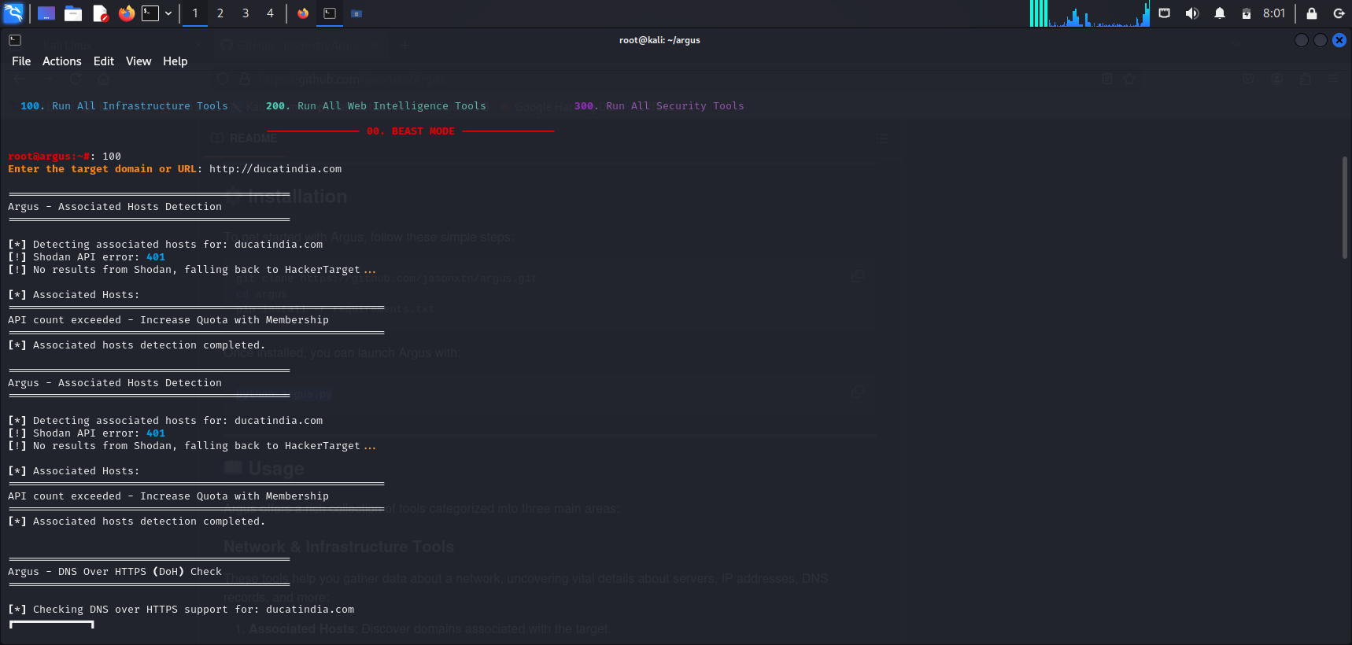

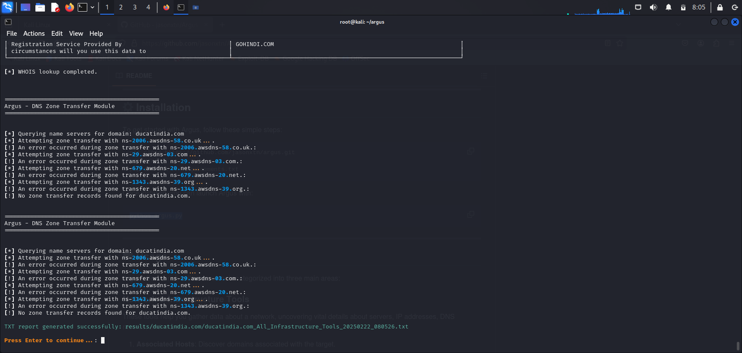

**Step 6: Open the location where the results saved**

**Command Using:** 1) exit

1. cd results

3) ls

4) cd <http://ducatindia.com>

5) ls

6) cat ducatindia.com_All_Infrastructure_Tools_20250220_135202.txt

**• Evidence**

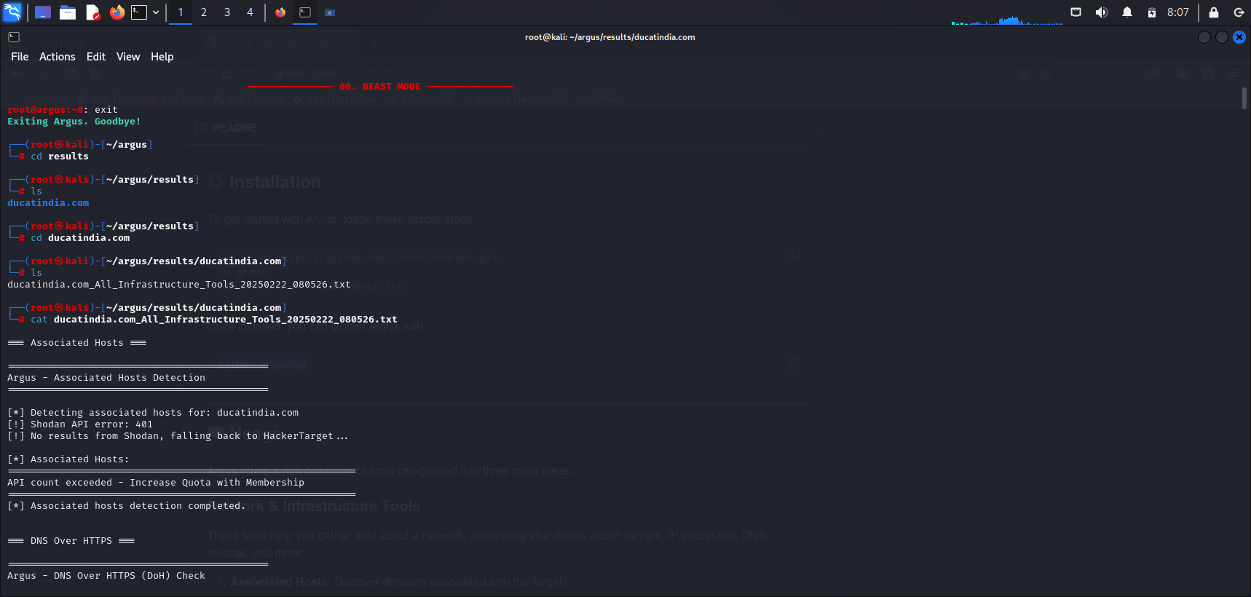

**Conclusion**

This assignment explains how to install, configure, and use Argus, a tool for gathering network information and monitoring traffic. By setting it up in Kali Linux, users can analyses network activity, detect vulnerabilities, and improve security. Argus helps cybersecurity professionals track and investigate network threats efficiently.